Griffiths Quantum Mechanics, 2nd Edition
Student Questionnaire

1) What are the main strengths of this book?
2) What are the main weaknesses as compared to other QM textbooks? Please give examples.
3) Do you have suggestions for changes to the overall approach of the author?
4) What other topics would you like to see covered in the text and/or in the class?
5) What could be done to make the text more “modern” and relevant to your interests and potential career?
6) Are there additional topics you would like to see covered in the existing chapters of the 2nd Edition?
7) Are there any chapters that have too much detail or irrelevant topics in the 2nd Edition?
8) What do you think of the writing style of the 2nd Edition? How could it be improved?
9) What do you think of having the questions (which often become HW problems) embedded in the text?
10) Is there any place in the text where the concepts are not clearly explained?
11) Does the book aim too high or too low in terms of mathematics or physical approach?
12) Are there any figures that are confusing, or figures that could be added to convey the message better?
13) What are the best online resources for studying quantum mechanics and for solving homework problems?
A new 3rd Edition is in the works. The publisher claims:
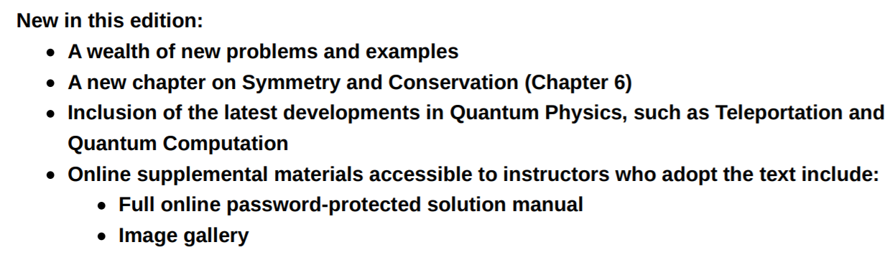
14) Do you have any other suggestions for the 3rd edition of Quantum Mechanics?
15) Would you like to see more explanation, more/better figures, more worked examples, more connection to experiments, more discussion of theoretical topics, etc.? Feel free to contribute.

http://www.cambridge.org/academic/subjects

